ISLAMIC UNIVERSITY OF TECHNOLOGY
Organization of Islamic Cooperation
Board Bazar, Gazipur

Mid-Semester Lab Exam
CSE 4512

IP Addresses of Hosts
Question: What is the IP address of PC1 of the subnetwork “Network1”?
Answer: 172.20.29.2
Question: What is the default gateway address of PC1 of the subnetwork “Network1”?
Answer: 172.20.29.1
Question: What is the IP address of PC2 of the subnetwork “Network1”?
Answer: 172.20.29.3
Question: What is the default gateway address of PC2 of the subnetwork “Network1”?
Answer: 172.20.29.1
Question: What is the IP address of PC3 of the subnetwork “Network2”?
Answer: 10.10.29.2
Question: What is the default gateway address of PC3 of the subnetwork “Network2”?
Answer: 10.10.29.1
Question: What is the IP address of PC4 of the subnetwork “Network2”?
Answer: 10.10.29.3
Question: What is the default gateway address of PC4 of the subnetwork “Network2”?
Answer: 10.10.29.1
Question: What is the IP address of PC5 of the subnetwork “Network3”?
Answer: 192.168.29.2
Question: What is the default gateway address of PC5 of the subnetwork “Network3”?
Answer: 192.168.29.1
Question: What is the IP address of PC6 of the subnetwork “Network3”?
Answer: 192.168.29.3
Question: What is the default gateway address of PC6 of the subnetwork “Network3”?
Answer: 192.168.29.1

IP Addresses of the interfaces of the Routers
Question: What is the IP address of the interface “serial0/1/0” of the Core Router?
Answer: 200.200.20.1

Question: What is the IP address of the interface “serial0/1/1” of the Core Router?
Answer: 200.200.20.5
Question: What is the IP address of the interface “serial0/2/0” of the Core Router?
Answer: 200.200.20.9
Question: What is the IP address of the interface “serial0/2/1” of the Core Router?
Answer: Not Used
Question: What is the IP address of the interface “serial0/1/0” of Router0 of the subnetwork “Network1”?
Answer: 200.200.20.2
Question: What is the IP address of the interface “serial0/1/1” of Router0 of the subnetwork “Network1”?
Answer: Not Used
Question: What is the IP address of the interface “serial0/2/0” of Router0 of the subnetwork “Network1”?
Answer: Not Used

Question: What is the IP address of the interface “serial0/2/1” of Router0 of the subnetwork “Network1”?
Answer: Not Used
Question: What is the IP address of the interface “serial0/1/0” of Router1 of the subnetwork “Network2”?
Answer: 200.200.20.6
Question: What is the IP address of the interface “serial0/1/1” of Router1 of the subnetwork “Network2”?
Answer: Not Used
Question: What is the IP address of the interface “serial0/2/0” of Router1 of the subnetwork “Network2”?
Answer: Not Used
Question: What is the IP address of the interface “serial0/2/1” of Router1 of the subnetwork “Network2”?
Answer: Not Used
Question: What is the IP address of the interface “serial0/1/0” of Router2 of the subnetwork “Network3”?
Answer: 200.200.20.10
Question: What is the IP address of the interface “serial0/1/1” of Router2 of the subnetwork “Network3”?
Answer: Not Used
Question: What is the IP address of the interface “serial0/2/0” of Router2 of the subnetwork “Network3”?
Answer: Not Used
Question: What is the IP address of the interface “serial0/2/1” of Router2 of the subnetwork “Network3”?
Answer: Not Used
Question: What is the Router ID of the router “Router2” of the subnetwork “Network3” after the configuration of OSPF routing?
Answer: 200.200.20.10

Screenshot of the routing table of the Routers
Question: Add a screenshot of the routing table of Router0 of the subnetwork “Network1”.
Answer:
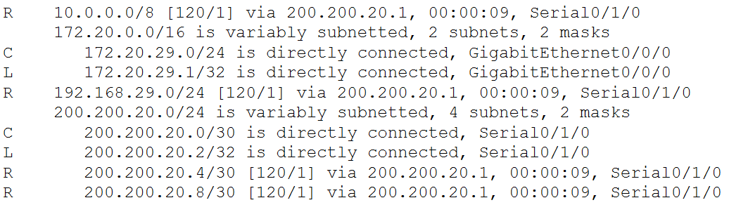
Question: Add a screenshot of the routing table of Router1 of the subnetwork “Network2”.
Answer:
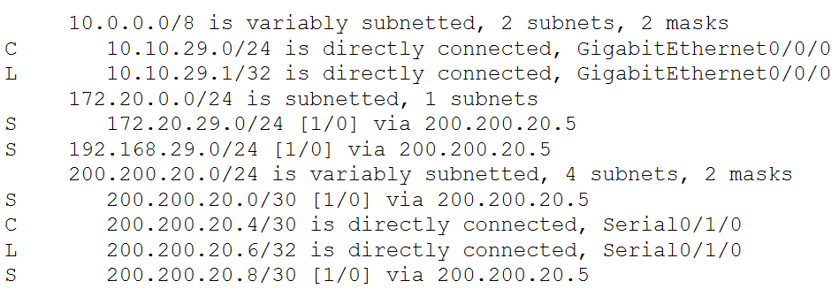

Question: Add a screenshot of the routing table of Router2 of the subnetwork “Network3”.
Answer:
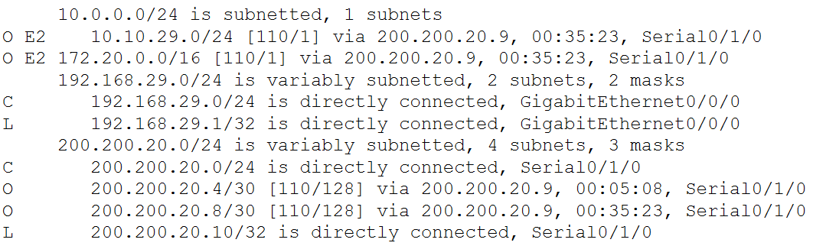
Question: Add a screenshot of the routing table of the Core Router.
Answer:
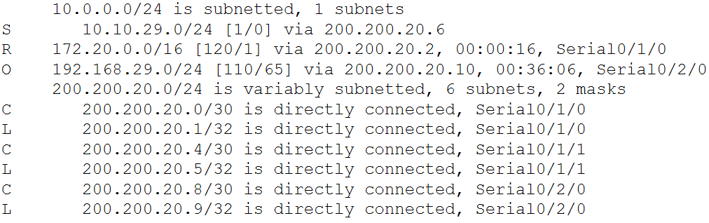

Question: Add a screenshot of the complete topology with proper labelling after configuration.
Answer:
